Setting up your own Dropbox
1. Go to https://www.dropbox.com/
2. Type your first name, last name, email address and a password.
3. Click “I agree to Dropbox terms” and “Sign Up.”
4. When asked to install Dropbox, click Cancel.
5. You now have a Dropbox account!
6. Click on Dropbox in the upper left corner two times, until you see folders.
7. To upload files, click on the white paper icon with the blue arrow:

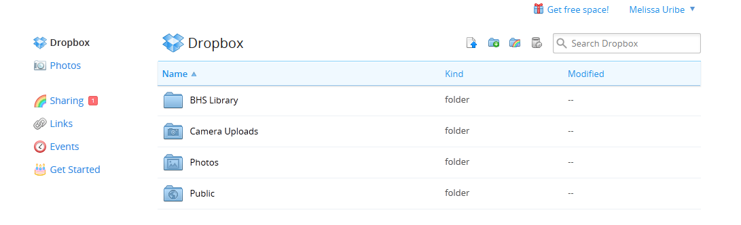
8. Click on Choose File.
9. Select the file you wish to save in your dropbox from the file where it is located on your computer; click open. The file will load to dropbox. Click done.
9. Once you save files to your dropbox, you can access them online at www.dropbox.com from any computer.

