MLA Database Citations –Works Cited and Parenthetical
I. Works Cited
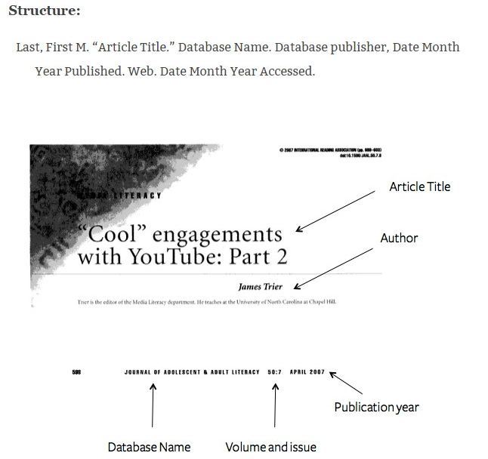

Example:
Trier, James. “‘Cool’ Engagements with YouTube: Part 2.” Journal of Adolescent & Adult Literacy 50.7 (2007): 598-603. JSTOR. Web. 16 Oct. 2014.
*Sources will be listed on the works cited page in alphabetical order with a hanging indention.
For additional information about formatting your works cited page, see the following website: https://owl.english.purdue.edu/owl/resource/747/05/
II. Parenthetical
Parenthetical citations are used to show which parts of your paper reference specific sources from your works cited page. Generally, you will provide the last name of the author and the specific page numbers of the source.
Double agents are still widely in use (Spies 12-15, 17).
With prices of energy at new highs, bikes have been increasingly used (“Alternative Transportation” 89).
*Citing online sources
Refer to the author, and if possible, a permanent identifier that would be the same for any reader.
Examples:
The economy will rebound with the new monetary policies (Smith).
Solar power will become the primary source of energy (Williams 2).
*Citing online sources with no author
If there is no author, use the title that begins the citation, either the article or website title. Be sure it also takes the same formatting, i.e. articles are in quotes and website titles are italicized. Shorten / abbreviate the name of the source but ensure that your reader can easily identify it in your works cited (abbreviate the title starting with the same word in which it is alphabetized).
Examples:
Elephants are thought to be one of the smartest mammals (“Smart Elephants”).
Nineteen men and women were convicted (Salem Witchcraft Trials).
Where to put the parenthetical citations:
- Place parenthetical citations at the end of the sentence you are paraphrasing and quoting. For example: The destruction of the argentine is due to many socioeconomic factors (Taylor 33).
- Even when quoting, place the parenthetical citations after the quotations.
Example:
“Mamma always said stupid is as stupid does” (Gump 89).
Long quotes:
When quoting four lines or more, indent every line you are quoting by one inch (or 10 spaces) and do not use quotes.
Example:
The use of nuclear weapons in today’s society is strikingly alarming. Though the United States is the only country to employ it in the past, they are at the same time the country that condemns its use the most. While this may seem hypocritical, is it the most proper action for the United States to make as the global leader. (Taparia 9)

